Test Engagement: Test management Tools.

**1.Technology Stack**

1. **ADO**
2. **TestRail**
3. **Test Link**
4. **QMetry**
5. **Jira**
6. **PractiTest**
7. **Xray**

**2. High level diagram**

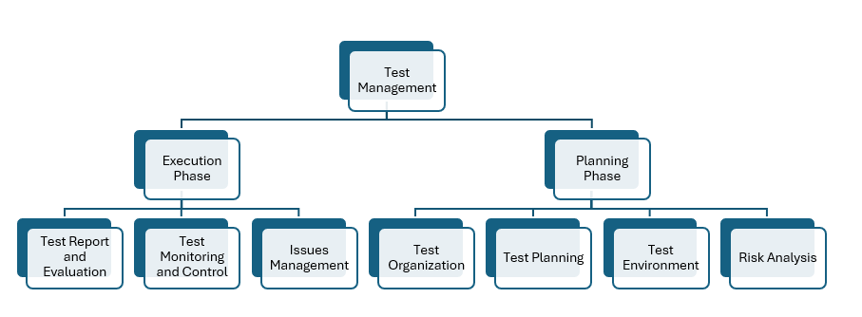

**3. High level usage**

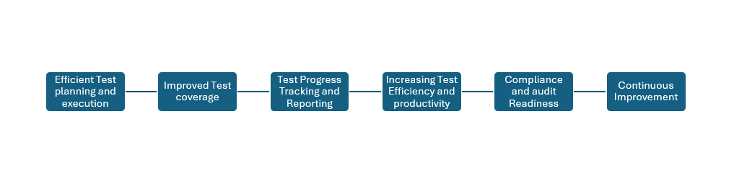

**4. Integration Approach**

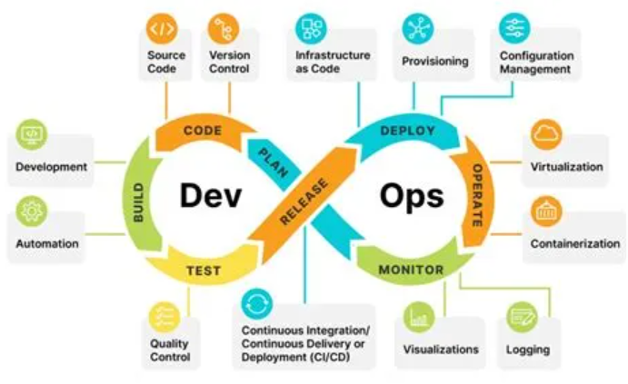

**5. When to Use/Consider Test Management Tools:**

When you need to efficiently plan, organize, carry out, and monitor your testing activities, test management tools like TestRail and Xray—or any other tool listed above—come in handy.

**The following situations call for the use of test management tools:**

1. Complex Testing Scenarios
2. Team Collaboration:
3. Traceability and Coverage:
4. Test Planning and Scheduling:
5. Reporting and Metrics:
6. Integration with Other Tools:
7. Regulatory Compliance
8. Test Automation Management
9. Reusability and Maintenance:

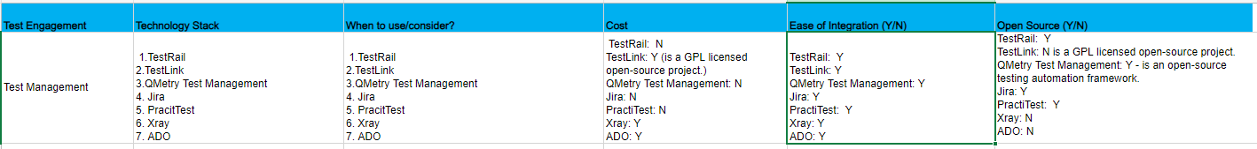

**6. ADO as a test management tool**

**Work item tracking:** ADO is very powerful and easy to use in terms of tracking test plans related to work items such as testcases test suites defects. Each individual team creates their own projects, tests, test suite you can edit, Prioritize the work items as-well for tracking and visibility in terms of testing efforts in terms of work.

**Integration with Agile Process:** ADO can be seamlessly integrated with agile methodologies, in terms of daily activities and sprint wise.

**Test Planning and Execution:** ADO provides flexibility for teams to create their tests in azure test plan, test suites to organize test cases and execute test cases manually or through automation.

**Automated Testing:** ADO supports Automated testing and integration with Azure Pipeline, Team members can create automated test scripts using frameworks like Selenium, JMeter or any other tools and can be executed through different CI/CD Pipelines. Test results are automatically logged back and reported to ADO.

**Test Case Management:** ADO Provides various basic test management capabilities, allowing team members to collaborate and create and maintain test cases directly within the Platform. Test cases are aligned with requirements and linked to work items for traceability Purposes.

**Traceability and Reporting:** ADO offers traceability features that enables the team to trace testcase back to requirements or features or PBI, in addition to this traceability ADO has built-in reporting, analytics tools to track the test progress of tasks,

**Collaboration and communication:** ADO provides collaboration within the team members through features, internal resources can discuss test-related issues and send feedback to the stakeholders and collaborate within the team effectively.

**Customizations and Extensibility: ADO** is highly customizable and extensible in terms of tailor made to specific test management requirements, and can be customizable for fields, process templates and extensions can be used to adapt as management tool for different testing workflows.